Name of Student : Raghav Mahesh Sarda PRN: 25070122235
Subject: Programming with Java Semester: III
ASSIGNMENT No : 21 Year: AY 2026-27
TITLE : JDBC DriverManager, Connection, and Statement

Problem Statement
Demonstration and exploration of JDBC classes and interfaces (DriverManager, Connection, Statement).

Learning Objectives
To understand and use the core JDBC classes for database connectivity.

Program:
student_db.sql
CREATE DATABASE student_db;
USE student_db;

CREATE TABLE connection_test (
test_id INT PRIMARY KEY,
status VARCHAR(50)
);

INSERT INTO connection_test VALUES (1, 'Database Operational');

DBConnectionTest.java
// Assignment 21 - Exercise 1: Connect Java with Database and Display Status
import java.sql.*;
public class DBConnectionTest
{
public static void main(String args[]) // Main Method
{
String url = "jdbc:mysql://localhost:3306/student_db"; // Database URL
String user = "thegharkalaptop"; // DB Username
String pass = ""; // DB Password

try // Try block
{
System.out.println("Loading MySQL JDBC Driver..."); // Driver loading message
Class.forName("com.mysql.cj.jdbc.Driver"); // Loading driver dynamically
System.out.println("Driver loaded successfully!");

System.out.println("Attempting connection to database server..."); // Attempt message
Connection con = DriverManager.getConnection(url, user, pass); // Establishing connection using DriverManager

if(con != null && !con.isClosed()) // Verifying connection status
{
System.out.println("\n[SUCCESS] Database Connection Status: CONNECTED"); // Status confirmation
System.out.println("Connected to: " + con.getMetaData().getDatabaseProductName());
System.out.println("Driver Version: " + con.getMetaData().getDriverVersion()); // Displaying driver version
}
else // Closed condition
{
System.out.println("\n[FAILED] Database Connection Status: NOT CONNECTED"); // Failure status
}

con.close(); // Closing connection session
System.out.println("Database connection closed cleanly.");
}
catch(ClassNotFoundException e) // Catching missing driver jar
{
System.out.println("Driver Error: MySQL JDBC Driver not found in classpath!"); // Driver error
}
catch(SQLException e) // Catching connection/credential errors
{
System.out.println("SQL Connection Error: " + e.getMessage()); // SQL error
}
}
}

StudentDBConnection.java
// Assignment 21 - Exercise 2: Connect to Student Database and Display Confirmation Message
import java.sql.*;

public class StudentDBConnection
{
public static void main(String args[]) // Main Method
{
String url = "jdbc:mysql://localhost:3306/student_db"; // URL targeting student_db
String user = "thegharkalaptop"; // DB Username
String pass = ""; // DB Password

try // Exception handling block
{
Class.forName("com.mysql.cj.jdbc.Driver"); // Registering driver
Connection con = DriverManager.getConnection(url, user, pass); // Connecting via DriverManager

if(con != null && !con.isClosed()) // Validating connection
{
String dbName = con.getCatalog(); // Fetching current database name from connection session
System.out.println("Connection Status: ACTIVE");
System.out.println("Message: The " + dbName + " database is connected successfully!");

Statement stmt = con.createStatement(); // Creating Statement to explore interface
ResultSet rs = stmt.executeQuery("SELECT DATABASE()"); // Querying active DB catalog
if(rs.next())
{
System.out.println("Verified Active Catalog from Server: " + rs.getString(1));
}

rs.close(); // Closing ResultSet
stmt.close(); // Closing Statement
}
con.close(); // Closing Connection
}
catch(Exception e) // Catching general connection exceptions
{
System.out.println("Connection Failed: " + e.getMessage()); // Error message
}
}
}

Output:
DBConnectionTest.java
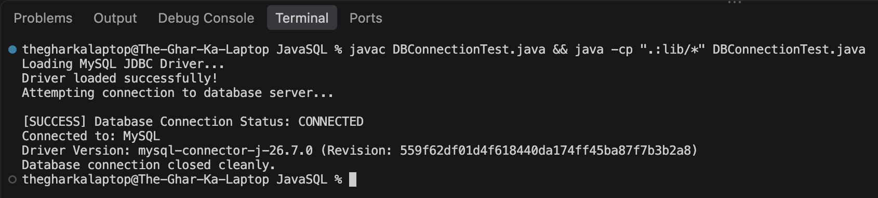
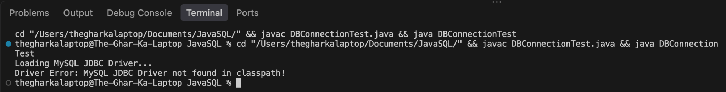

StudentDBConnection.java
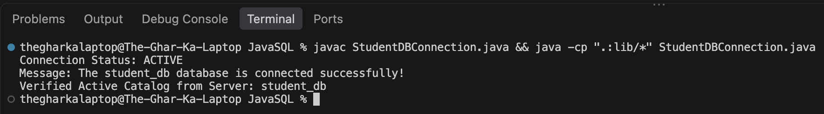
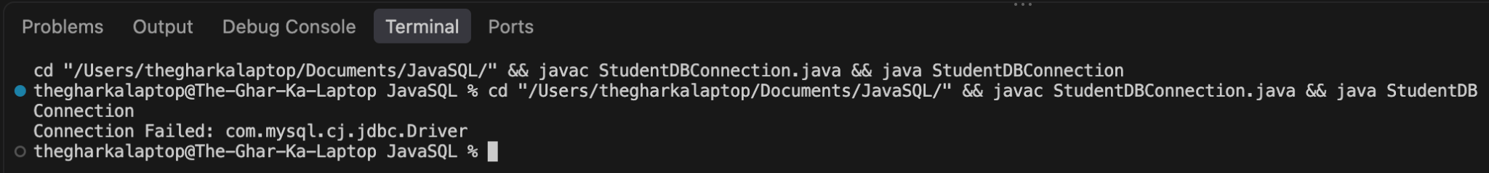

Conclusion:
In this assignment, the foundational JDBC classes and interfaces, DriverManager, Connection, and Statement, were explored and verified for establishing reliable database communications. The DriverManager successfully registered the MySQL driver and managed authentication sessions, the Connection interface maintained an active bridge to the student_db schema, and the Statement interface executed metadata queries to evaluate system readiness, demonstrating the core mechanics of Java database connectivity.

